Digital Systems Project Report (ECE 241)

Project Name: Electric guitar
Teaching Assistant:
Team Members: Student Number:
Rui Zeng 1003979091

1.Introduction
2. The Design
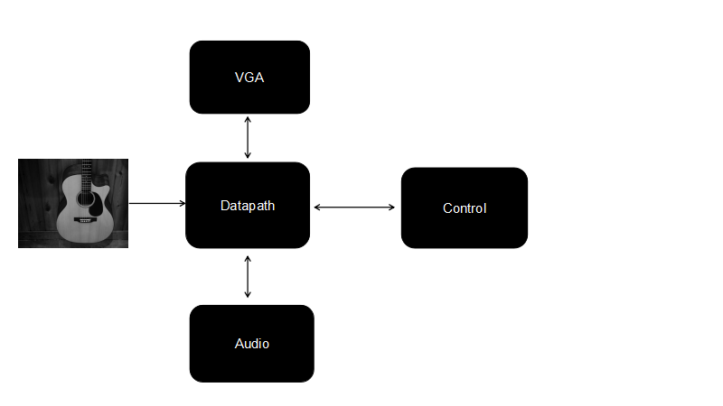
Figure Design Block Diagram

Acoustic Guitar
The Acoustic guitar serves as the major user input. The sensor is attached to six strings and 4 frets (metal strips placed along the fret board) of the guitar. When the string is vibrating or the fret is pressed, the electric signals are sent back to the GPIO_0 of the FPGA board and serve as the inputs to the Data path module.

Control
The Control module gets the instructions from user using switches. It then calls corresponding stages in the FSM. The major parts for FSM are the Recording stage and the Replaying stage and gives out 5 main control signals to the Data path module.
The 5 signals provided are:
- resetn: For reset all the registers and counters in the Data path module.
- is_record: To tell the Data path it is in recording mode.
- is_play: To tell the Data path it is in playing mode
- go: Is a signal during recording. When go is 1, the note signals from the GPIO_0 are loaded into ram in and stored in 1 address. When go is 0, the address in ram will increment by 1 and be ready to take the next note signals.
- reset_address: To tell the Data path that the recording mode is started or the replaying mode is started and the address in the ram should be reset.

Data path
The Data Path module gets the signals from the Acoustic guitar and the Control module and sends signals to the Audio module and VGA module for audio and visual output.
The major part for the Data path is a 32x64 ram. The GPIO_0, signals are converted to [31:0]Note bits signal which represent 1 note played by the user.

Audio

VGA

3. Report on Success

